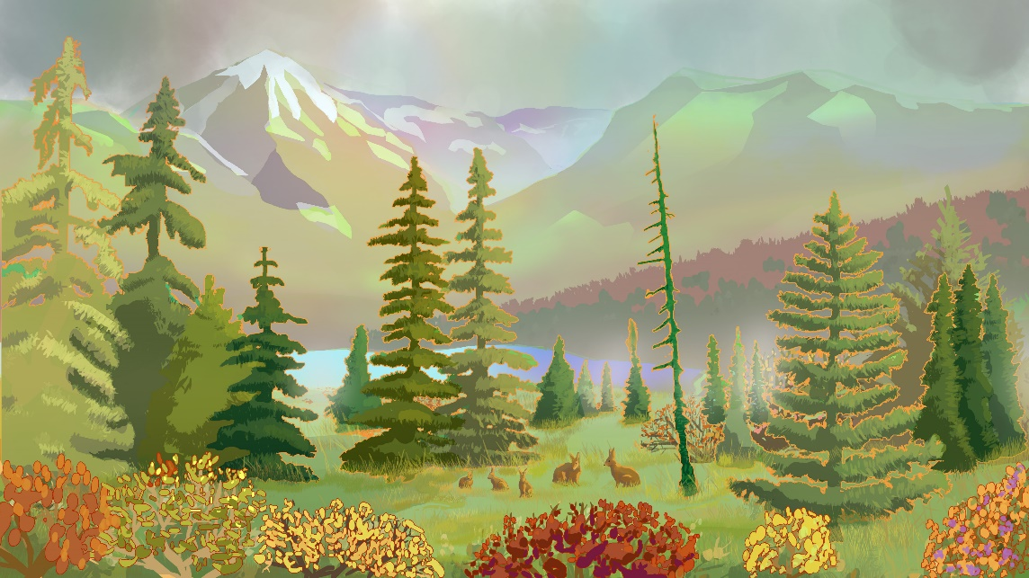  Autumn |  |   Autumn

To get started right away, just tap any placeholder text (such as this) and start typing to replace it with your own or delete for a blank card. |  | To get started right away, just tap any placeholder text (such as this) and start typing to replace it with your own or delete for a blank card.

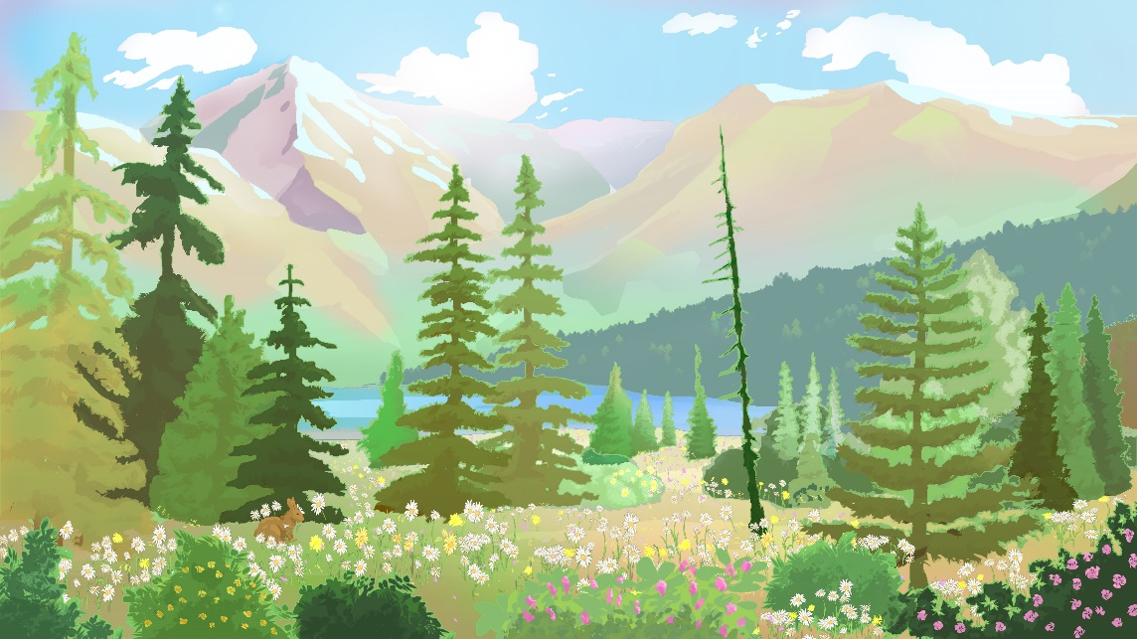  Spring |  |   Spring

To get started right away, just tap any placeholder text (such as this) and start typing to replace it with your own or delete for a blank card. |  | To get started right away, just tap any placeholder text (such as this) and start typing to replace it with your own or delete for a blank card.

To get started right away, just tap any placeholder text (such as this) and start typing to replace it with your own or delete for a blank card. |  | To get started right away, just tap any placeholder text (such as this) and start typing to replace it with your own or delete for a blank card.

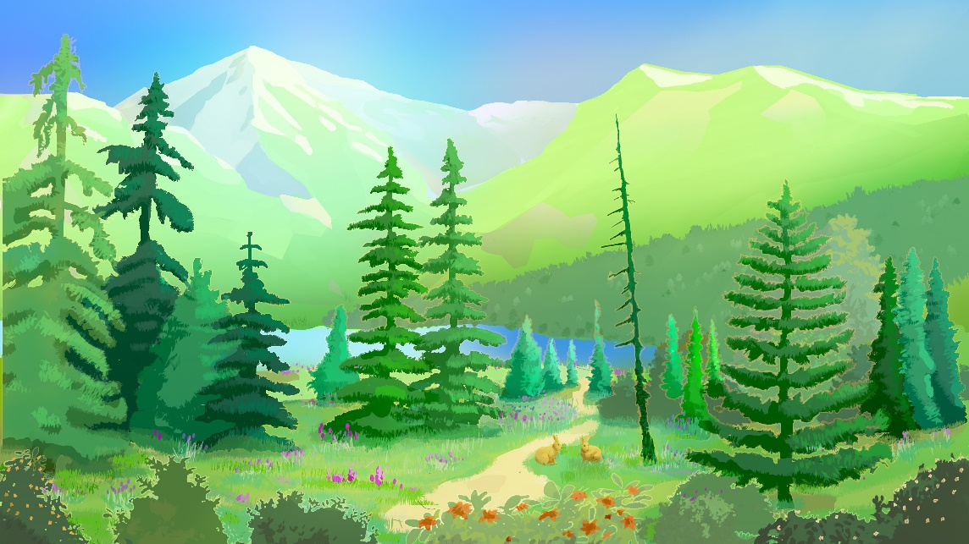  Summer |  |   Summer

To get started right away, just tap any placeholder text (such as this) and start typing to replace it with your own or delete for a blank card. |  | To get started right away, just tap any placeholder text (such as this) and start typing to replace it with your own or delete for a blank card.

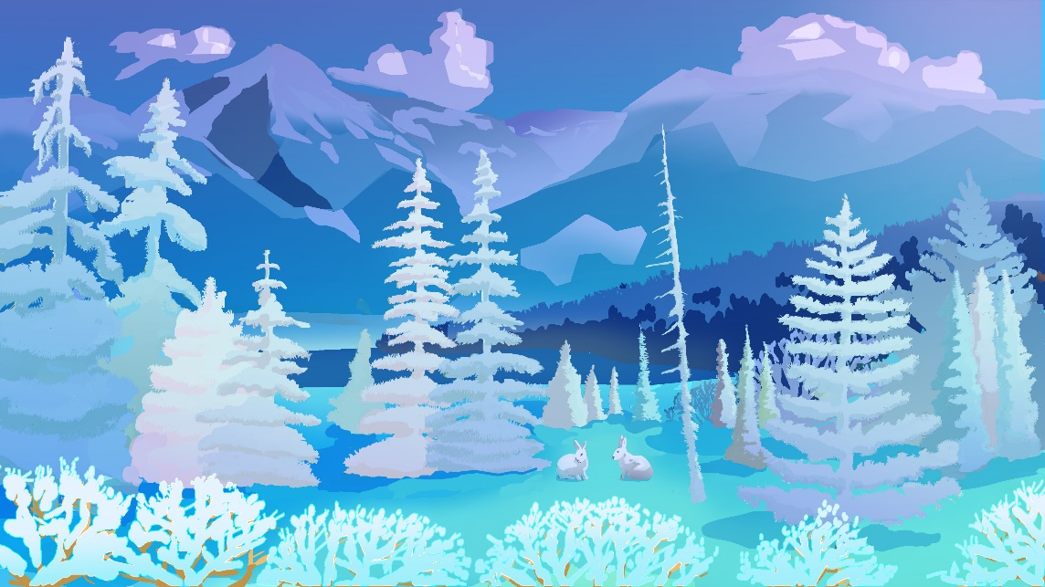  Winter |  |   Winter

To get started right away, just tap any placeholder text (such as this) and start typing to replace it with your own or delete for a blank card. |  | To get started right away, just tap any placeholder text (such as this) and start typing to replace it with your own or delete for a blank card.

